Virtual Cultural Exchange Project

Culture, Self-Concept, and Self-Esteem

This course fulfills one of the curriculum requirements of the International Scholars Program because it places special emphasis on culture and its influences on human development. As part of this course requirements, you will participate in a virtual cultural exchange with students from two other universities. This assignment includes two parts, and you must complete both to receive a grade.

Part 1 Instructions:

You will engage virtually with students from this class as well as with students from two other universities via Flip. Flip is a free app from Microsoft, developed for students. You will be accessing flip outside your Canvas shell. Please go to flip.com and create an account or sign in. Then, you will have to join our group: xxxxxxxxx. All discussion question topics have been created and posted at the beginning of the semester. There are 5 discussion questions posted separately for the students from DEP3053 (UF), São Paulo State University and Shimane University. Please post your videos for discussion marked for UF students. Finally, please remember that for the students from the São Paulo State University and Shimane Universities English is their second language; therefore, when you post your videos try to speak a little slower and clearer, so everyone can understand. If there is a function to add subtitles to your videos, please use it.

You are required (1) to respond to all 5 flip discussion questions posted by your instructor, (2) to respond to at least 2 other students’ videos within flip group, and (3) to respond to any questions posted to your videos within the time frame outline for virtual exchange (see syllabus for beginning and end of virtual exchange). Make sure that you post your original videos within the topics designated for your class. To respond to other students’ posts, you can simply choose the discussion topic with their respective university/country.

For example, one of the discussion questions is “What is your self-identity” (see below).

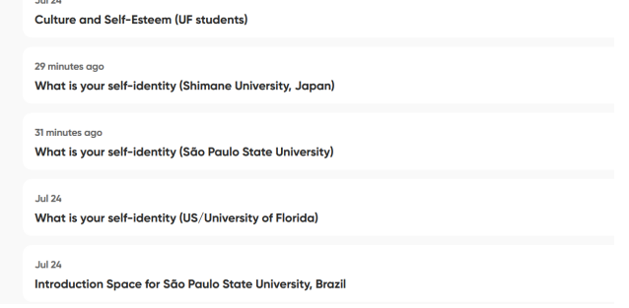
You, as a UF student, should post in the discussion marked US/University of Florida (see below)
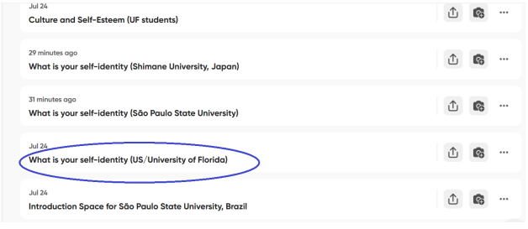

And if you would like to see responses to the same question from the students from Japan, simply go into the discussion post marked for Shimane University, Japan.

You can go beyond the basic requirements and respond to more videos. The more you interact and learn from your peers, the better your paper will turn out.

The goal of the participation in flip discussions is to learn about cultural differences and similarities in the development of self-concept and self-esteem and to write a paper describing what you learned. Ultimately, your paper will be your reflection on the topic of cultural
influences on the development of self-concept and self-esteem. You will have to use the information that you learned from your textbook, my videos, and your interaction with the students from Brazil and Japan.

Part 2 Instructions:

Next, you will write a brief, between 1- and 2-pages, reflection paper. See syllabus for due date. The focus of the paper should be on discussing any effects of culture on self-concept and/or self-esteem. It should be based primarily on your interaction with the students from UF (many UF students also come from diverse cultural backgrounds), Japan, and Brazil via Flip. In other words, the purpose of this reflection is not to regurgitate the information from the textbook or my videos, but rather to apply theories, studies and concepts to real life experiences shared by your peers, which may or may not support the information from the course. For example, you may hear that the experiences and opinions across the three cultures are very similar, or you may find some differences that illustrate what was presented to you in our videos and/or textbook. You will summarize the similarities or differences and give a few examples to illustrate your points (do not give any personal information, e.g., names, etc.) Keep in mind that this is a very short reflection paper. You may focus only on self-concept or self-esteem, or both. Finally, conclude your paper by stating whether learning about other cultures have helped you better understand your own culture and its influences on your development. Explain. This should be about one or two paragraphs.

You are not required to cite any sources, however, if you are quoting a definition or a concept that was described in your textbook, my videos or an article, please cite it properly in text and at the end of the paper (reference page). The reference page will not count towards the page limit.

Formatting and Other Instructions for the Paper:
- The main body of your paper will be 1-2 pages (double-spaced, 1” margins, 12 pt. standard font).
- Put your name at the top of the first page or include a separate title page. • Please number all pages.
- Make certain you submit it in Microsoft Word format, either in 97-2003 format or a more recent version (2007 or 2010 are fine).
- After you submit your paper, go back and check the format of the submitted paper. Students, who use Mac especially, should double check to make sure that the format of the submitted paper was not corrupted or converted to the wrong format after the submission.
- (Optional) Include a reference page if you cite any sources and provide full reference(s).

How to cite your sources:

In-Text Citation (Paraphrase or Quotation):

(Klimenko, 2019)

Full Reference at the end of the paper:
Klimenko, M. (2019). Lecture 2: How to Cite in APA[PowerPoint slides]. Retrieved from University of Florida Developmental Psychology Canvas: https://ufl.instructure.com/courses/339342

In-Text Citation (Paraphrase or Quotation):

(Feldman, 2022, 11.1)

Full Reference at the end of the paper:
Feldman, R. S. (2022). Life span development: A topical approach (4th ed.). Pearson Education, Inc.

Example of Citing an Article

In-Text Citation (Paraphrase or Quotation):

(Smith, 2017)

References

Smith, R. A. How to cite in APA. Developmental Psychology Journal, 28, 223-224.

Grading:

This assignment is worth 5% points. The grade will be based on both, your participation in flip, and the quality of your paper. If you do not complete flip participation, you will automatically receive a 0 on your reflection paper. Papers cannot be submitted late, and you will receive a 0. Detection of plagiarism will result in a 0.

Criteria | Incomplete/ Missing | Needs more work | Complete
Cultural similarities and/or differences are discussed. | Not discussed or too many errors which detract from | Insufficiently or clearly enough to understand the paper or with errors which | Sufficiently, clearly, sources cited properly (2)
Citations, if necessary, are included | understanding the paper (0) | detract from understanding the paper. Or source(s) not properly or never cited (1)
Examples from Flip participation | Not provided or not relevant at all (0) | Insufficient or unclear to understand the paper (1) | Sufficiently, clearly (2)
Reflection on one’s own culture | Missing | Insufficiently or not clearly explained (0.5) | Sufficiently and clearly explained (1)

